7.1 Exploring Exponential Models
Objective: To model exponential growth and decay

Exponential Function: involves the expression b^{x}; where the Base b is a positive number other than 1 (ex: 2^{x})

Asymptote: a line that a graph approaches as you move away from the origin (Barrier)

Characteristics of the Exponential Function;
Using the function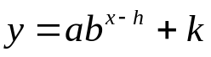,
h translates the graph horizontal h units
k translates the graph vertical k units

Graphing:
- Use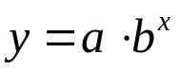as base graph (use t-chart; y – intercept=(0,a))
- Shift Points: h = horizontal shift, k = vertical shift
- Asymptote = k
- Domain = all real numbers
- Range = y > k if a > 0 (graph goes up if a is positive)
and y < k if a < 0 (graph goes down if a is negative)

Exponential Growth: when a>0 and b > 1 (ex: 2^{x})
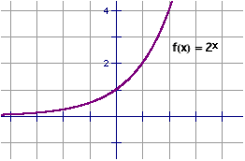
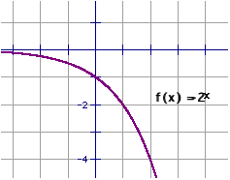

Exponential Decay: when a>0 and 0 < b < 1 (ex: 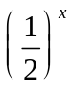)

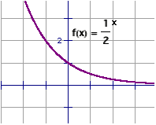
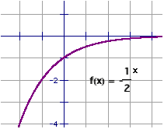

Examples:
State whether f(x) is an exponential growth or decay function.
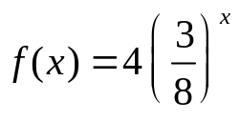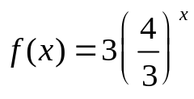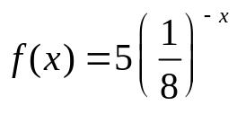

Decay, 0<3/8<1 Growth, 4/3>0 Growth 8>0

Graph the function → ( use an x/y chart from -3 to 3. )
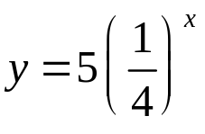

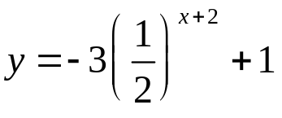

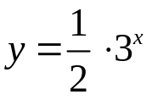

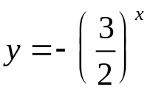

Exponential Growth Model: when a quantity increases by a fixed percent each interval
y = a(1 + r)^{t}
- a = initial amount
- r = percent increase (expressed as a decimal)
- t = time (years)
- 1 + r = Growth Factor

Exponential Decay Model: when a quantity decreases by a fixed percent each interval
y = a(1 - r)^{t}
- a = initial amount
- r = percent decrease (expressed as a decimal)
- t = time (years)
- 1 – r = Decay Factor

Example: In January 1993, there were about 1,313,000 Internet hosts. During the next five years, the number of hosts increased by about 100% per year.

a) Write a model giving the number h (in millions) of hosts t years after 1993. About how many hosts were there in 1996?

b) Graph the model

c) Use the graph to estimate the year when there were 30 million hosts.
You buy a new car for $24,000. The value y of the car decreases by 16% each year.

a) Write an exponential decay model for the value of the car. Use the model to estimate the value after 2 years.

b) Graph the model

c) Use the graph to estimate when the car will have a value of $12,000

Write an exponential decay model that describes the situation.

An adult takes 400 milligrams of ibuprofen. Each hour h, the amount i of ibuprofen in the person’s system decreases by about 29%.

The amount y (in grams) of a sample of iodine – 131 after t days is given by y = 50(0.92)^{t}.

a) Identify the initial amount of the substance.

b) What percent of the substance decays each day?

c) How many grams of the substance is left after 1 week?

Hmwk: page 439 #7-9, 11, 13, 19-25 (odd), 27

